Remote operation of the GOLEM tokamak with hydrogen and helium plasmas
V Svoboda¹, A Dvornova², R Dejarnac³, M Prochazka⁴, S Zaprianov⁵, R Akhmethanov⁷, M Bogdanova⁸, M Dimitrova^{3,6}, Zh Dimitrov⁵, O Grover¹, L Hlavata⁴, K Ivanov⁵, K Kruglov⁷, P Marinova⁶, P Masherov⁷, A Mogulkin⁷, J Mlynar^{1,3}, J Stockel^{1,3}, A Volynets⁸
¹Faculty of Nuclear Physics and Physical Engineering CTU, Prague, Czech Republic
²Moscow Engineering Physics Institute (MePhi), Moscow, Russian Federation
³Institute of Plasma Physics, AS CR, Za Slovankou 3, 182 00 Prague, Czech Republic
⁴Faculty of Chemistry, Brno University of Technology, Brno, Czech Republic
⁵St. Kliment Ohridski University of Sofia, Bulgaria
⁶Acad. E. Djakov Institute of Electronics, Bulgarian Academy of Sciences, Sofia, Bulgaria
⁷Research Institute of Applied Mechanics and Electrodynamics of Moscow Aviation Institute (National Research University), Moscow, Russia
⁸Faculty of Physics, M.V.Lomonosov Moscow State University, Moscow, Russia

stockel@ipp.cas.cz
Abstract. The GOLEM tokamak was operated remotely via Internet connection during the 6th International Workshop and Summer School on Plasma Physics. Performances of hydrogen and helium discharges are compared in this paper. It is found, at similar vacuum conditions, that helium discharges are shorter but the breakdown of the working gas can be quite easily achieved at almost the same loop voltage. The plasma current in helium discharges is slightly lower than in the case of hydrogen. Turbulent fluctuations of the floating potential measured by means of an array of Langmuir probes reveal a noticeably different character in the two discharges.
- Introduction
Remote operation of the GOLEM tokamak, which is located at the Czech Technical University in Prague, was performed on-line by twelve participants of the 6th International Workshop and Summer School on Plasma Physics in Kiten, Bulgaria. The plasma discharges were produced in hydrogen and helium as working gases and a comparison of performances of both types of discharges is presented in this paper. The GOLEM tokamak together with its state-of-the-art remote handling system are briefly described in section 2. Experimental results, including the optimization of the helium discharges, and the comparison of floating potential fluctuations measured by Langmuir probes (LPs), are presented in section 3.
- The GOLEM tokamak
2.1 Description and characteristics
The GOLEM tokamak is operational at the Faculty of Nuclear Physics and Physical Engineering (FNPPE), Czech Technical University in Prague [1]. GOLEM is a small tokamak which was constructed at the end of 1950's at the Kurchatov Institute, Moscow as TM-1. The tokamak was moved to the Institute of Plasma Physics in Prague in 1977 and re-named CASTOR [2]. After 30 years of operation, the tokamak was given to the FNPPE for education of students and renamed GOLEM.
The GOLEM tokamak has a circular cross section. The major/minor radii of the tokamak vessel are R₀ = 0.4 m, b= 0.1 m. The stainless steel vessel is equipped with a poloidal limiter (made of Molybdenum) of radius a = 0.085 m. The power supplies of individual windings are based on several condenser banks. Here, the condenser banks to supply the toroidal field coils and primary winding of the air core transformer are exploited.
The tokamak is equipped by a set of simple diagnostics, which measure the loop voltage, plasma current, toroidal magnetic field, and visible emission. GOLEM is also equipped with Mirnov coils, a visible spectrometer, an array of bolometers, a fast camera for time resolved pictures, etc... In the series of experiments described here, a radial array of 12 Langmuir probes is used.
Engineering and plasma parameters, which can be achieved on GOLEM are quite modest. The tokamak operates at maximum toroidal magnetic field of up to 0.5 T. The central electron temperature is less than 100 eV, the maximum line average density ~ 10¹⁹ m⁻³, the maximum pulse length is around 18 ms.
2.2 Remote handling of the GOLEM tokamak
A unique capability of the GOLEM tokamak is that it can be operated remotely via Internet [3]. Once agreed with the chief operator, the users connect to the web page displaying the remote control room of GOLEM, which is displayed as print screen in Figure 1.
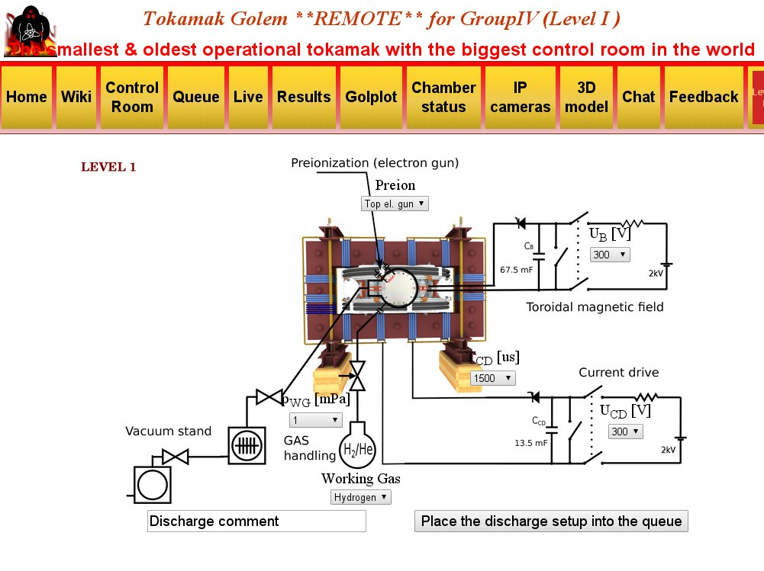
Figure 1. Virtual control room of the Golem tokamak used for remote operation.
Just six "buttons" shown in figure 1 are used to operate the tokamak. Participants select charging voltage of the condenser banks for powering the toroidal field coils (U_{B}) and the primary winding of the transformer (U_{CD}). Then, the time delay between trigger pulses of U_{B} and U_{CD} is also pre-selected (t_{CD}). Furthermore, the working gas (Hydrogen or Helium) and its filling pressure (p_{WG}) are chosen. One can also select the type of pre-ionization (microwave or electron gun). The selected discharge is commented and placed into the queue. Once the discharge is executed, the experimental results in form of temporal evolutions of basic plasma parameters, as well as resulting data files are available, when the option "Results" is selected on the yellow banner of the screen. Other knobs seen on the yellow banner in figure 1: Queue – position of the discharge to be executed in the queue, Live – views by web cameras of the torus hall and through a glass window into the tokamak vessel.
- Experimental results
The remote operation of GOLEM from Kiten is focused on the comparison of discharge performances in Hydrogen and Helium plasmas. In the past, the majority of GOLEM discharges were performed with Hydrogen as the working gas. However, some features of plasma performance in tokamaks are related to so-called isotope effects. This is important not only with respect to plasma physics but it has some practical consequences for ITER operation, since a campaign in Helium is planned in ITER after the initial phase in hydrogen. Some features like the threshold power for L-H transition in Helium plasmas should be predicted with sufficient precision well in advance. Therefore, the first task of the remote operation was devoted to optimization of He discharges. The second task is to compare the edge plasma turbulence in hydrogen and helium plasmas.

3.1 Optimization of helium discharges
First of all, an optimum set of input parameters had to be determined to get stable Helium discharges with the lowest loop voltage at the breakdown and the highest plasma current. It was found that a key parameter to get stable He discharge is to select a sufficiently high filling pressure of the working gas, as documented in figure 2.
Figure 2 displays temporal evolutions of the loop voltage for three discharges differing in the value of the filling pressure, with remaining input parameters being the same (U_{B} = 800 V, U_{CD} = 450 V, t__{CD} = 2 ms). We clearly see that a sufficiently high pressure of He is required to achieve a stable discharge without MHD instabilities. It has to be noted that the loop voltage is at acceptable level in all three cases with a break down less than 10 V, resulting in long discharges.
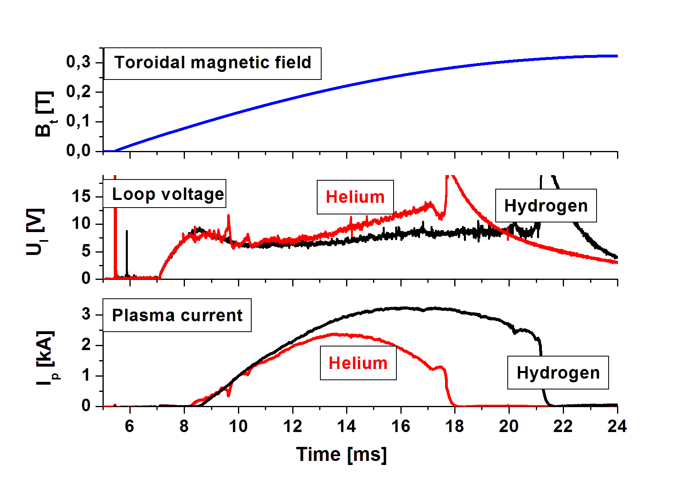
Figure 3. Comparison of the loop voltage and plasma current in He (#16339) and H (#16319) discharges at the filling pressure p =100 mPa.
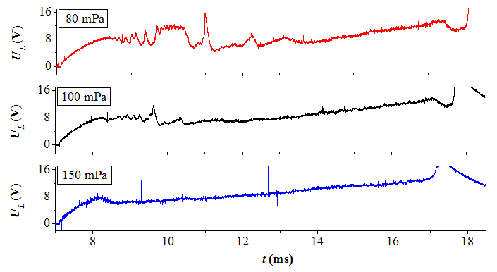

Figure 2. Evolution of the loop voltage of helium discharges at different pressures.
The next task is to find discharges in Hydrogen with similar performance. Figure 3 compares temporal evolutions of the loop voltage and plasma current for two discharges in Helium and Hydrogen. It has to be noted that operation in He or Hydrogen is preceded by glow discharge cleaning in Helium or Hydrogen, respectively. To find two identical discharges in both working gases was challenging and the best-achieved result is for shot #16319 and #16339 for time t < 13 ms.

3.2 Fluctuation measurements
Floating potential is measured using a radial array of Langmuir probes (the so-called rake probe) [4], which is shown in figure 4.
The rake probe consists of 16 molybdenum tips with diameter of 0.7 mm and length of 2 mm. However, only 12 tips are used in this experiment because of limitation of available data acquisition channels. The rake probe is inserted into the plasma from the bottom of the vessel. The first Langmuir probe (LP1) is the deepest located at r = 70 mm from the center of the tokamak vessel. The distance between the individual probes is 2.5 mm. Consequently, the probe LP7 is located at radius r = 85 mm, which corresponds to the radius of the GOLEM limiter, so probes LP8 – LP12 are in the limiter shadow with open magnetic field lines. The probe LP9 appears to be out of operation during described experiments. Probe signals are digitized at 1 MHz sampling rate and stored in the GOLEM database.
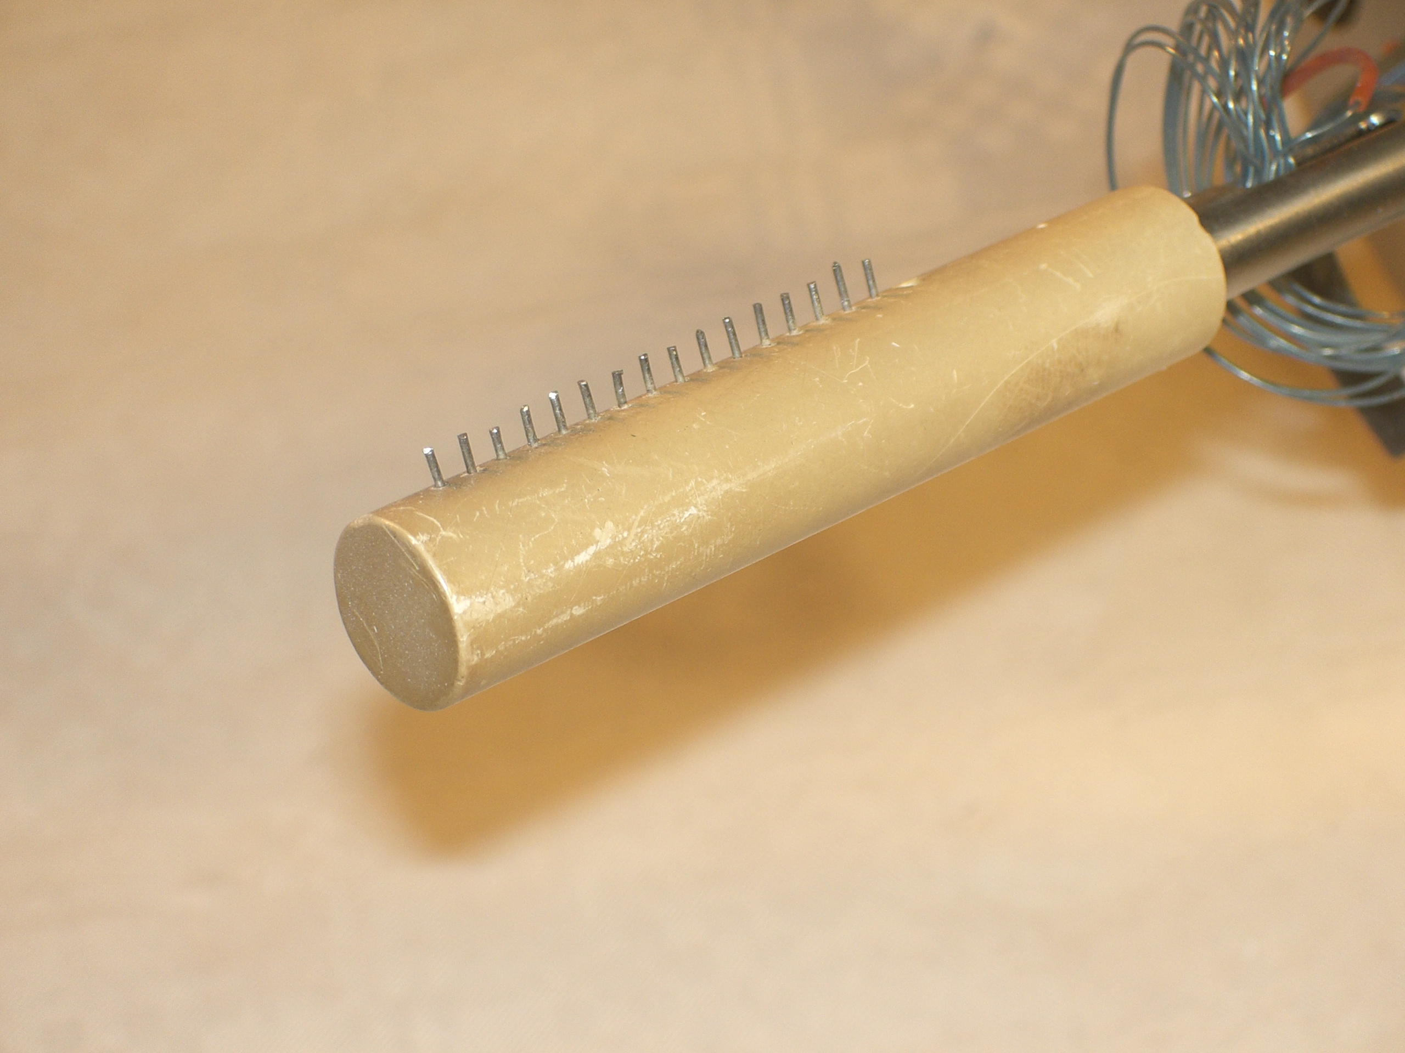
Figure 4. Picture of the rake probe. The insulating probe head is made of Boron Nitride.

About 53 discharges (#16293 - #16346) were executed during the remote session from Kiten. To compare properties of turbulent fluctuations in Helium and Hydrogen plasmas, we selected two discharges, which are characterized by a similar evolution of the loop voltage. Figure 4 compares discharges in Hydrogen (#16312) and in Helium (#16346). The temporal evolution and the maximum toroidal magnetic field are identical B_{T} = 0.33 T (U_{B} = 800 V) for both discharges. The capacitor bank for primary winding of the transformer is charged to U_{CD} =300 V (H) and U_{CD} = 200 V (He), respectively. It has to be noted that these values are below charging voltages usually used on GOLEM operation. The filling pressure of Helium is roughly twice that (79 mPa) of the H discharge (35 mPa).
It is seen in the figure that the loop voltage required for plasma breakdown is quite low in both discharges, 5.8 V for hydrogen plasma and even lower for helium discharge, 4.7 V. It has to be noted that the breakdown occurs at a quite low toroidal magnetic field, B_{T} = 0.052 T. However, the maximum value of the plasma current differs significantly in these discharges. In hydrogen plasma, the maximum plasma current is 2.5 kA, while only 0.97 kA is achieved in Helium plasma. In both cases, the discharges are stable, without any evident MHD instabilities. The discharge in Helium is shorter by about 2.5 ms than the Hydrogen one. Such shortening of He discharges is observed for all discharges in this remote operation campaign.
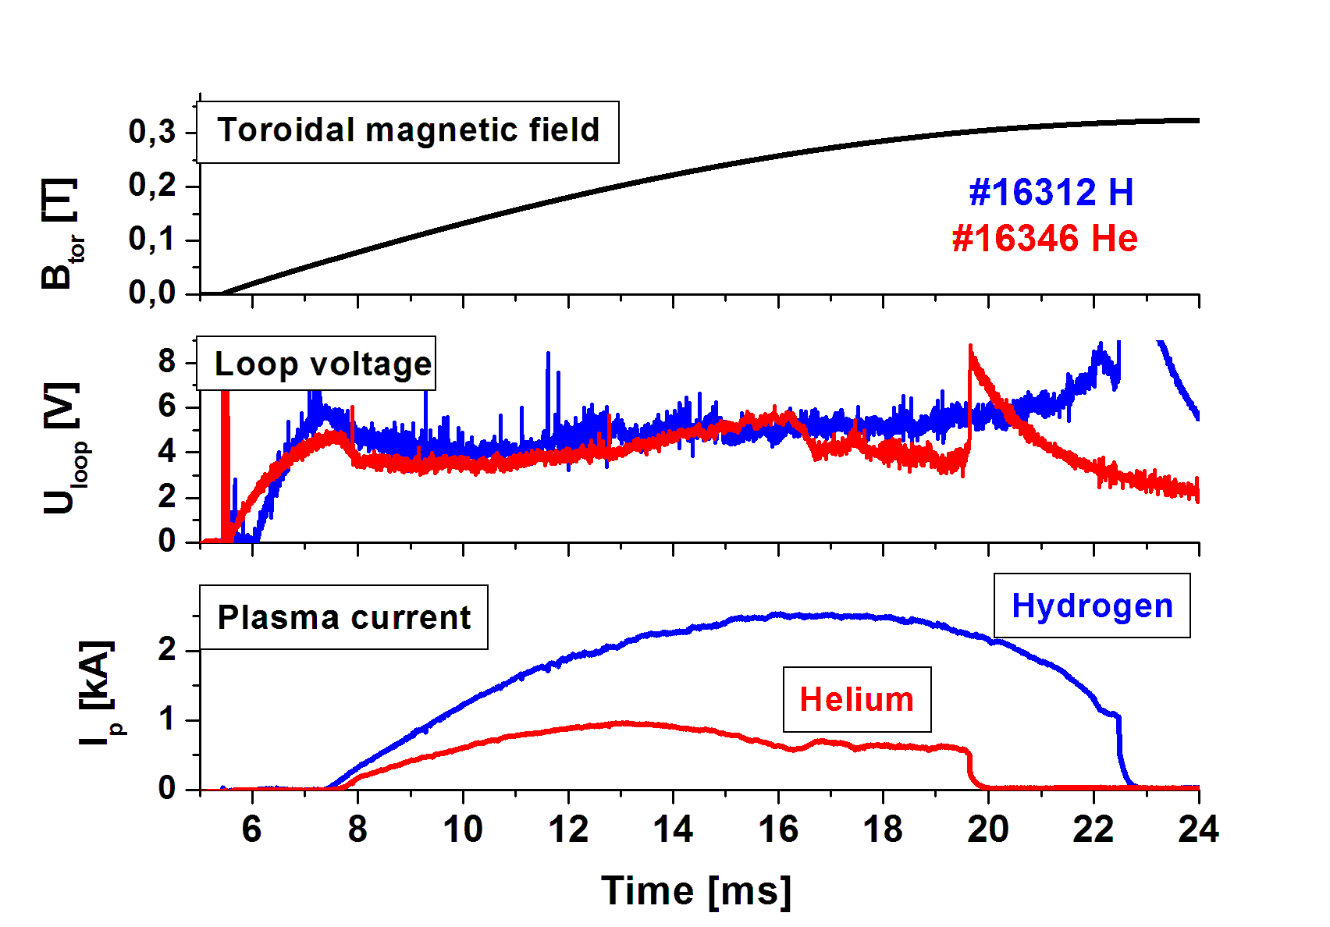
Figure 4. Comparison of the loop voltage and plasma current in and H (#16312) and He (#16346) discharges.
The signals of the floating potential of the probe LP1 are compared in figure 5.

It is seen that both probe signals are time dependent. The most probable explanation of such a variation of the V_{fl} mean values is a vertical (and also radial) movement of the plasma column during the discharge, GOLEM being not equipped with any feedback control for position. At the beginning of the He discharge, the floating potential is negative, which is typical for the probe located deep in the confined region of the plasma column [5], while the V_{fl} is positive for t > 16 ms. Therefore, we speculate that the plasma column moves from bottom to top during the discharge. Unfortunately, this speculation cannot be confirmed by magnetic diagnostics [6] or by fast tomography [7], because these diagnostics were out of operation during this experimental campaign. Therefore, to analyze turbulent fluctuations and to compare their H/He properties, we focus on a short time interval during the discharge where V_{fl} is relatively in steady state. We select a short time window of duration of Δt = 1 ms at time t = 10.5 ms when the floating potential is minimum.
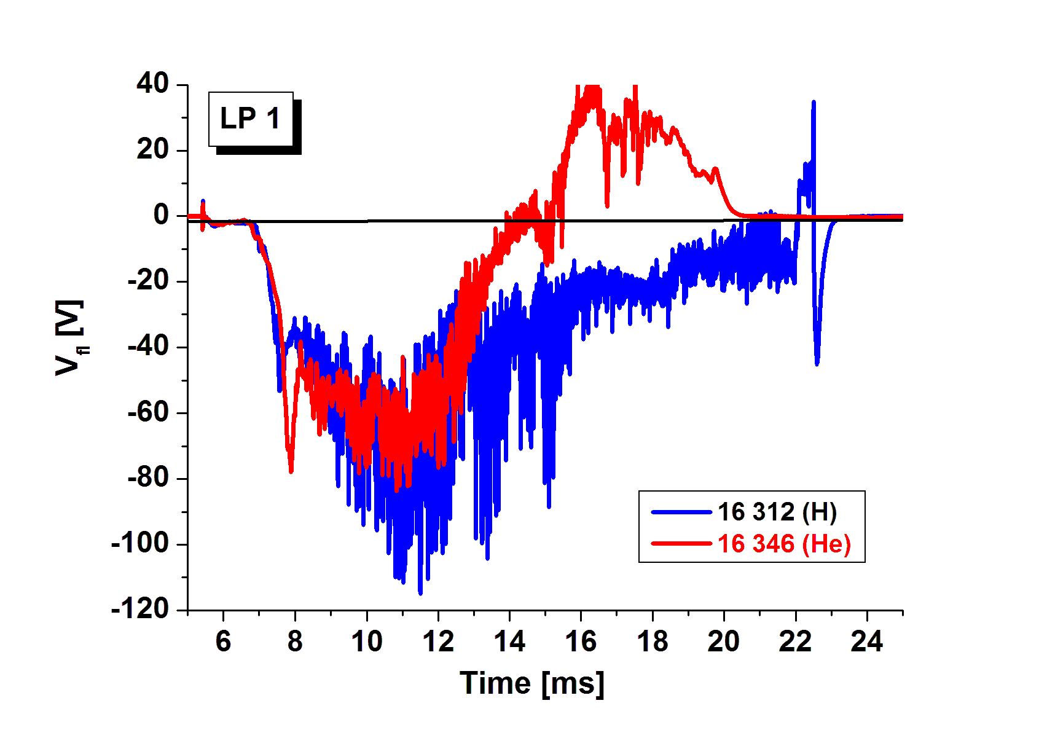
Figure 5. Comparison of the floating potential recorded by the probe LP1 in Hydrogen and He plasmas.
The radial profiles of the floating potential in Hydrogen and Helium discharges are compared in figure 6. The data are time averaged over Δt and the error bars correspond to the standard deviation around the mean value. In spite of different basic discharge parameters the radial profiles are almost identical. The slope of the profile -dV_{fl}/dr is proportional to the radial electric field (if we neglect the unknown gradient of the electron temperature) and is ~1.25 kV/m in both cases. Such value of the radial electric field causes a significant ExB velocity in the poloidal direction, which is around v_{pol}~1.25/0.16~7.8 km/s (with Bt = 0.16 at t = 10.5 ms). We note opposite gradients of V_{fl} between the probes LP1 and LP2 for the two discharges.
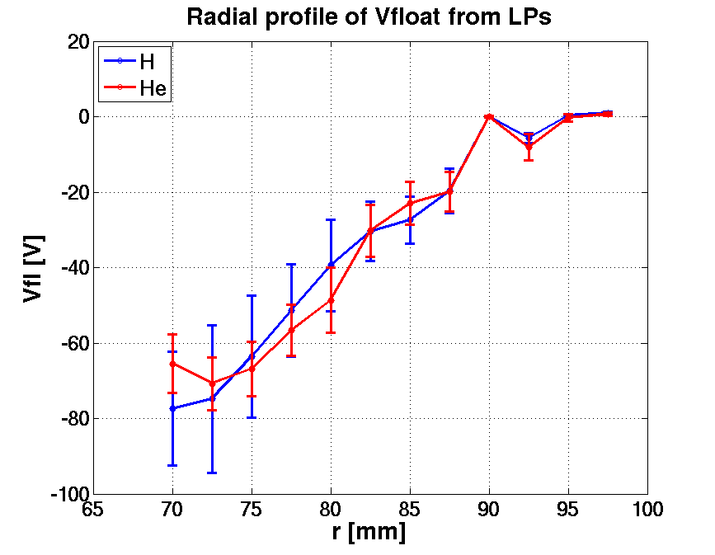Figure 6. Radial profiles of the floating potential in Hydrogen (blue) and Helium (red) discharges. Probe LP9 is out of operation.

Figure 7 compares the fluctuation component of the floating potential as measured by LP1 in Hydrogen and Helium discharges.
It is evident that the level of fluctuations is noticeably different for the entire duration of the discharges, significantly smaller in the case of He plasma, for the deepest probe.
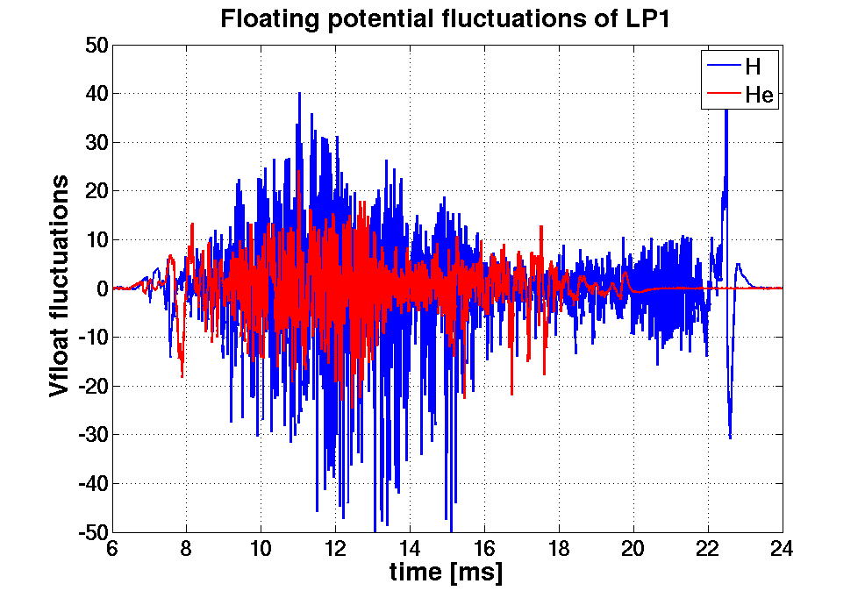Figure 7. Fluctuations of the floating potential in Hydrogen (#16312-blue) and Helium (#16346-red) discharges as recorded by the probe LP1.
A detailed comparison of the V_{fl} fluctuations properties for all LPs is presented in figure 8 with the Probability Distribution Function (PDF) as measured by probes LP1 – LP8.

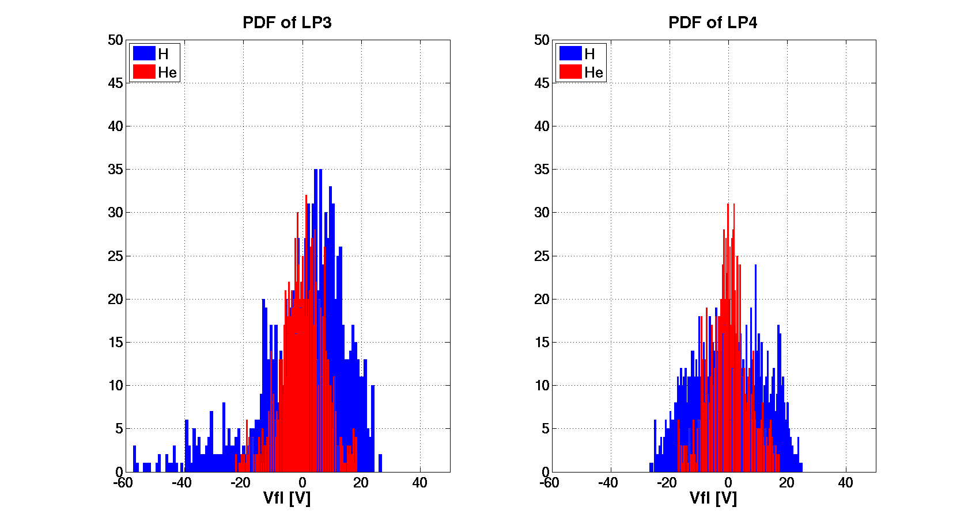
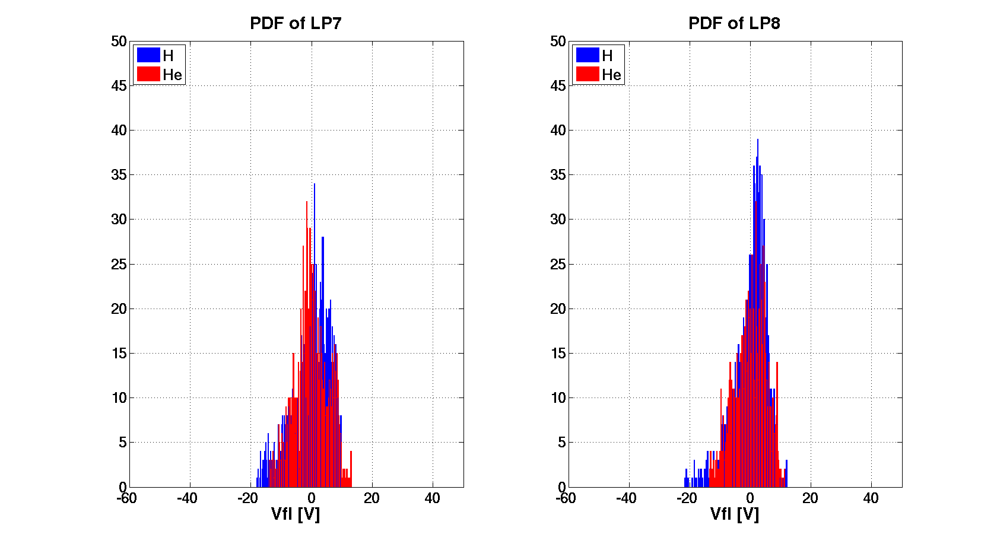
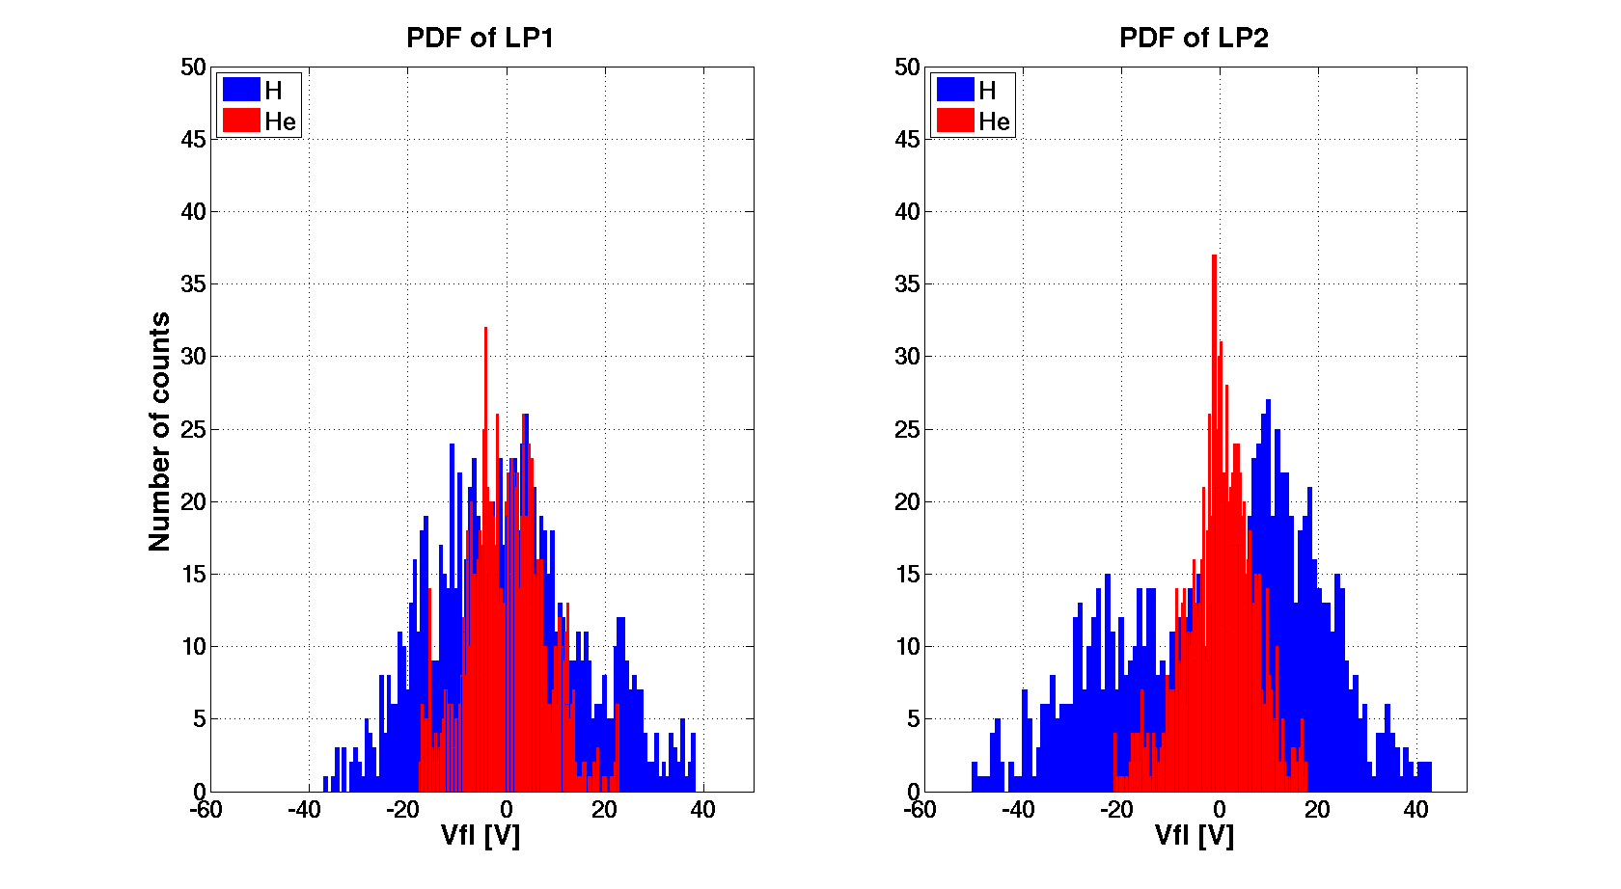
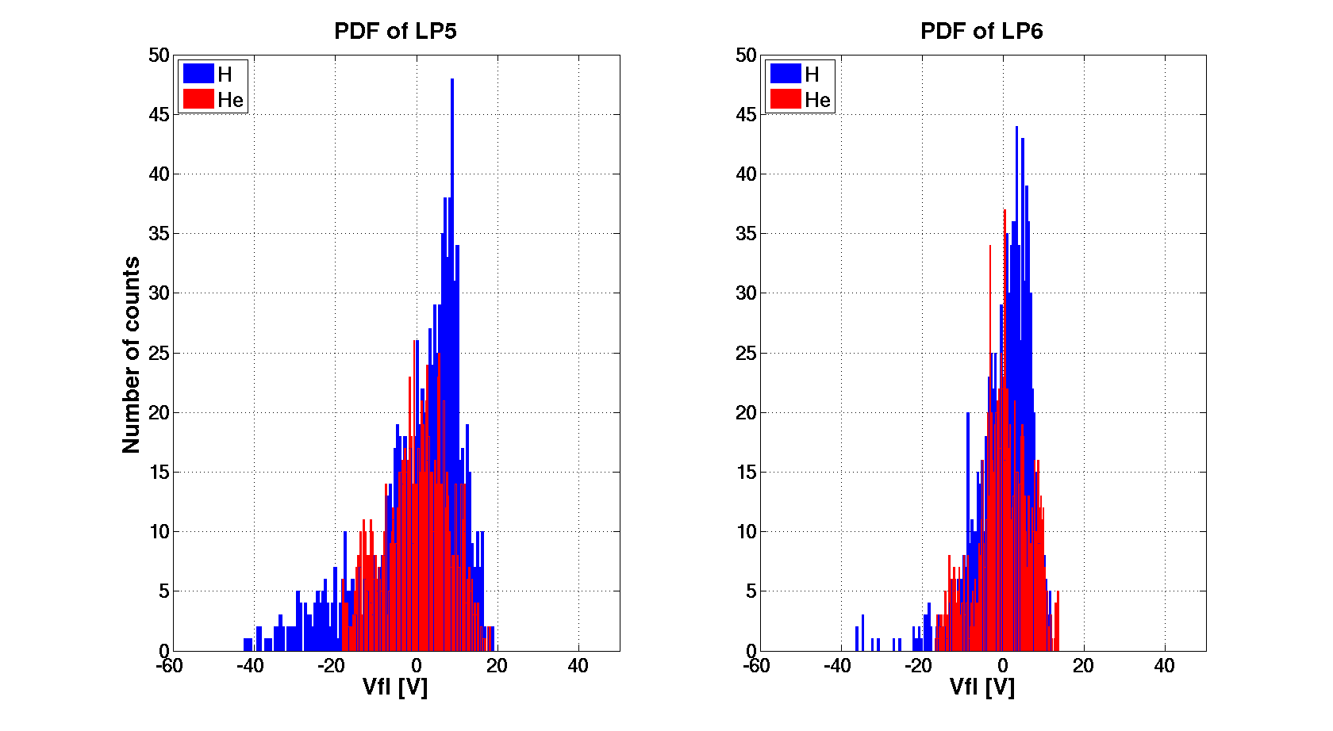
Figure 8. PDF of V_{fl} fluctuations in H (#16312) and He (#16346) discharges for probes LP1 –LP8.

It is evident that the shape of PDF depends on the probe position inside the plasma column. The PDFs in Hydrogen are broader than in Helium, except the probes LP7 and LP8, which are located in the limiter shadow. The Probability Distribution Functions look mostly Gaussian in Helium plasma, while negative tails in the floating potential are evident in the Hydrogen discharge.
Figure 9 compares the power spectra in H and He for the same probes.
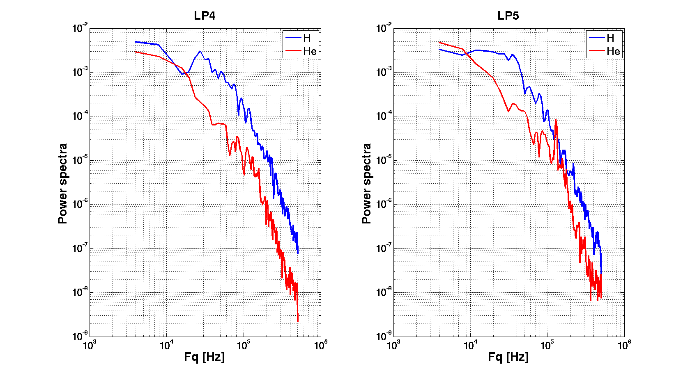

Figure 9. Power spectra of V_{fl} fluctuations in H and He discharges for probes LP4 (left) and LP5 (right).

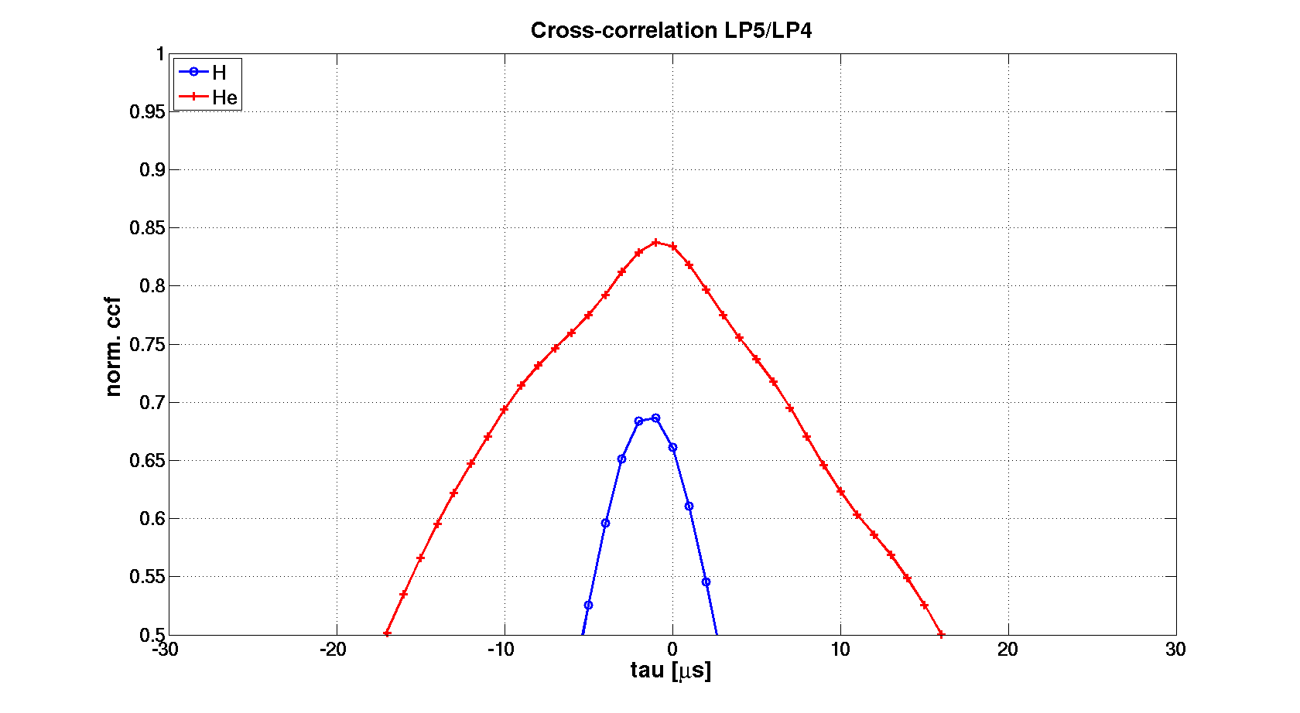
A characteristic peak of fluctuation power is seen in hydrogen plasma at f = 28 kHz, which is missing in Helium. A high frequency peak in Helium plasma localized around 120 kHz is present.
Figure 10 displays an example of the cross correlation between two probes, radially spaced by d = 2.5 mm.
Figure 10. Cross correlation between probes 4 and 5 in H and He discharges. Zoom around the maximum is inserted.

The cross correlation between probes LP4 and LP5 is significant in H and He discharges, being 70 - 80%. The negative time lag, τ = -1 μs at the maximum of the cross correlation function, evident from the insert in figure 8, would imply a radial propagation of turbulent structures from LP4 to LP5. The velocity of this turbulent structure, or blob [8], can be simply estimated as v_radial = d/τ = 2.5 km/s.
- Conclusions
We demonstrate here that the GOLEM tokamak is a unique facility, which is effectively used for motivating students for fusion research and their practical training anywhere in the world in a simple, remote way. Furthermore, interesting experimental results can be achieved. The remote operation of GOLEM from the Kiten workshop was focused on comparative studies of plasma performance by using Hydrogen and Helium as working gases. We clearly show that Helium plasma is easily generated with plasma parameters comparable with Hydrogen plasma, which is not standard in other tokamaks. Therefore, this feature allows the study of isotope effects, which might be important for larger tokamak facilities. We focus on the comparison of turbulent fluctuations properties of the floating potential in H/He plasmas. The floating potential is measured by a radial array of 12 Langmuir probes covering the limiter shadow as well as part of the confined plasma. We demonstrate that in He plasma the level of V_{fl} fluctuations is noticeably lower, that the Probability Distribution Function is closer to a Gaussian, and that the frequency spectra differ from those measured in Hydrogen plasma.
It is evident that additional experiments have to be performed and more sophisticated analyses to be exploited to get better insight of these isotope effects.

Acknowledgments
This work was partially supported by the project RVO: 68407700 of the Czech Technical University in Prague. Additional support has been granted from IAEA technical contract CRP F1.30.14 on “Utilization of the Network of Small Magnetic Confinement Fusion Devices for Mainstream Fusion Research”. The opinions expressed by authors do not necessarily represent the positions of the European Commission neither IAEA.
References

- V. Svoboda,G. Pokol, D. I. Réfy, J. Stöckel, G. Vondrášek Former tokamak CASTOR becomes remotely controllable GOLEM at the Czech Technical University in Prague, 37th EPS Conference on Plasma Physics, Dublin, June 2010
- Stockel J, Badalec J, Duran I, Hron M, Horacek J, Jakubka K, Kryska L, Petrzilka J, Zacek F, Heller MVP, Brazilio ZA, Caldas IL: Magnetic and electrostatic fluctuations in the CASTOR tokamak, Plasma Phys Contr Fusion 41 A577-A585 Suppl. 3A 1999
- V. Svoboda, B. Huang, J. Mlynar, G.I. Pokol, J. Stöckel, G. Vondrasek, Multi-mode remote participation on the GOLEM tokamak, Fusion Engineering and Design 86 (2011) 1310–1314
- J Stöckel, J Adamek, P Balan, O Bilyk, J Brotankova, R Dejarnac, P Devynck, I Duran, J P Gunn, M Hron, J Horacek, C Ionita, M Kocan, E Martines, R Panek, P Peleman, R Schrittwieser, G Van Oost, F Zacek, Advanced probes for edge plasma diagnostics on the CASTOR tokamak, Journal of Physics, Conference Series, 63 (2007), 012001More references
- J. Brotankova, J. Stockel, J. Horacek, J. Seidl, Measurement of Sheared Flows in the Edge Plasma of the CASTOR Tokamak, ISSN 1063_780X, Plasma Physics Reports, 2009, Vol. 35, No. 11, pp. 980–986.
- O. Ficker , O. Grover, J. Kocman, J. Krbec, V. Loffeman, T. Markovic, M. Matusu, J. Stockel, V. Svoboda, J. Veverka, G. Vondrasek, Tokamak GOLEM for fusion education chapter 5, EPS 41st Conference on Plasma Physics, Berlin June 2014, P4.141
- T. Odstrcil, M. Odstrcil, O Grower, V, Svoboda, I. Duran, J. Mlynar, Low cost alternative of high speed visible light camera for tokamak experiments, Rev. Sci. Instrum. 83, 10E505 (2012); http://dx.doi.org/10.1063/1.4731003
- S Krasheninnikov et al, Large plasma pressure perturbations and radial convective transport in a tokamak, J. Plasma Physics Research Series, Vol 6., (2004), 139-143

