Experimental Set-up
In order to study the temporal and spatial evolution of the electron temperature and plasma density in the tokamak GOLEM, we used a Langmuir triple probe in the voltage mode. We have exploited the existing linear array of the Langmuir probes, so called rake probe. The rake probe is composed of 16 Langmuir tips spaced by 2.5 mm. The tips are made of Molybdenum wire of the diameter 0,7 mm. The length of individual tips is about 2 mm. The rake probe is inserted in the tokamak vessel from bottom, as schematically shown in Fig. 1.

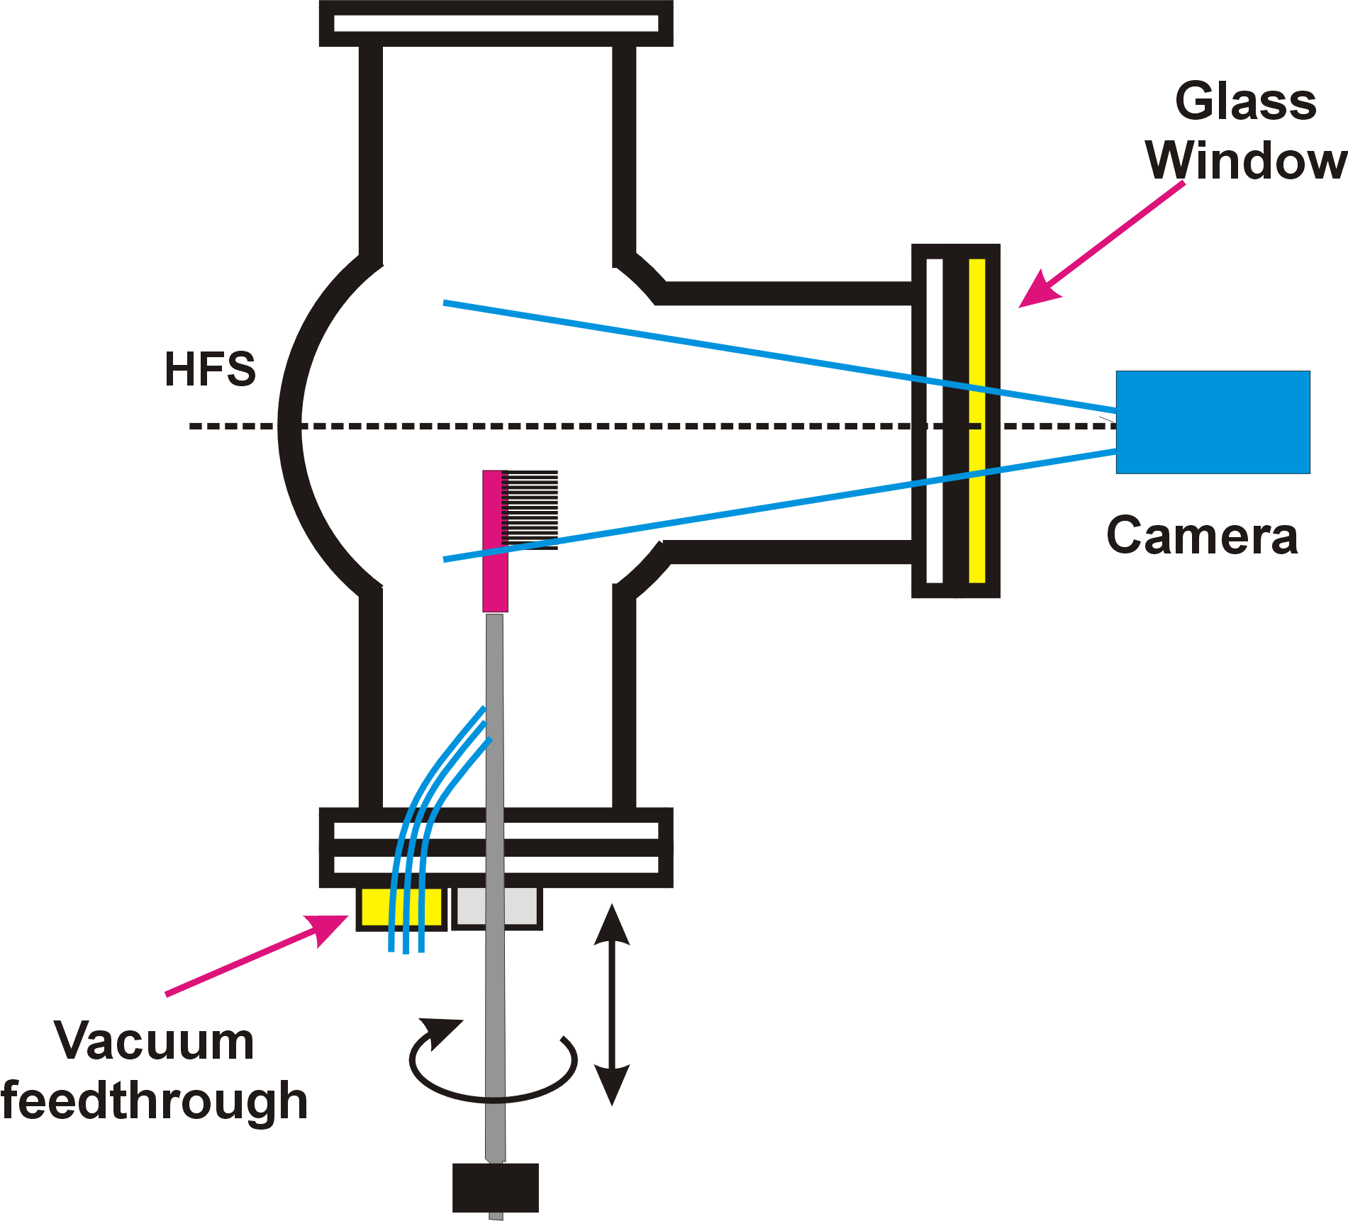
Fig 1 Lay-out of the experiment

The first tip of the rake probe was placed at r = 66mm from the center of the tokamak chamber.The rake probe is installed on the rotatable shaft, therefore, it was possible to change orientation of the tips with respect to the direction of the toroidal magnetic field and the plasma current.

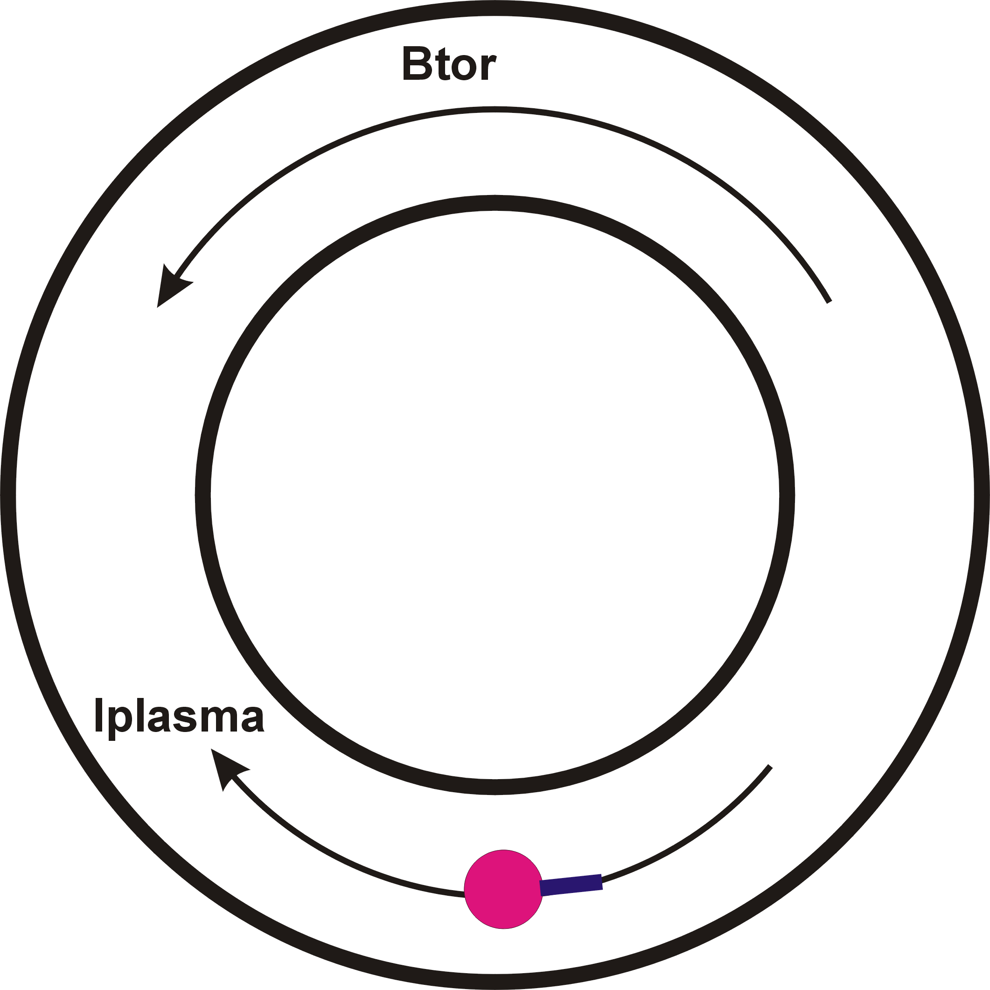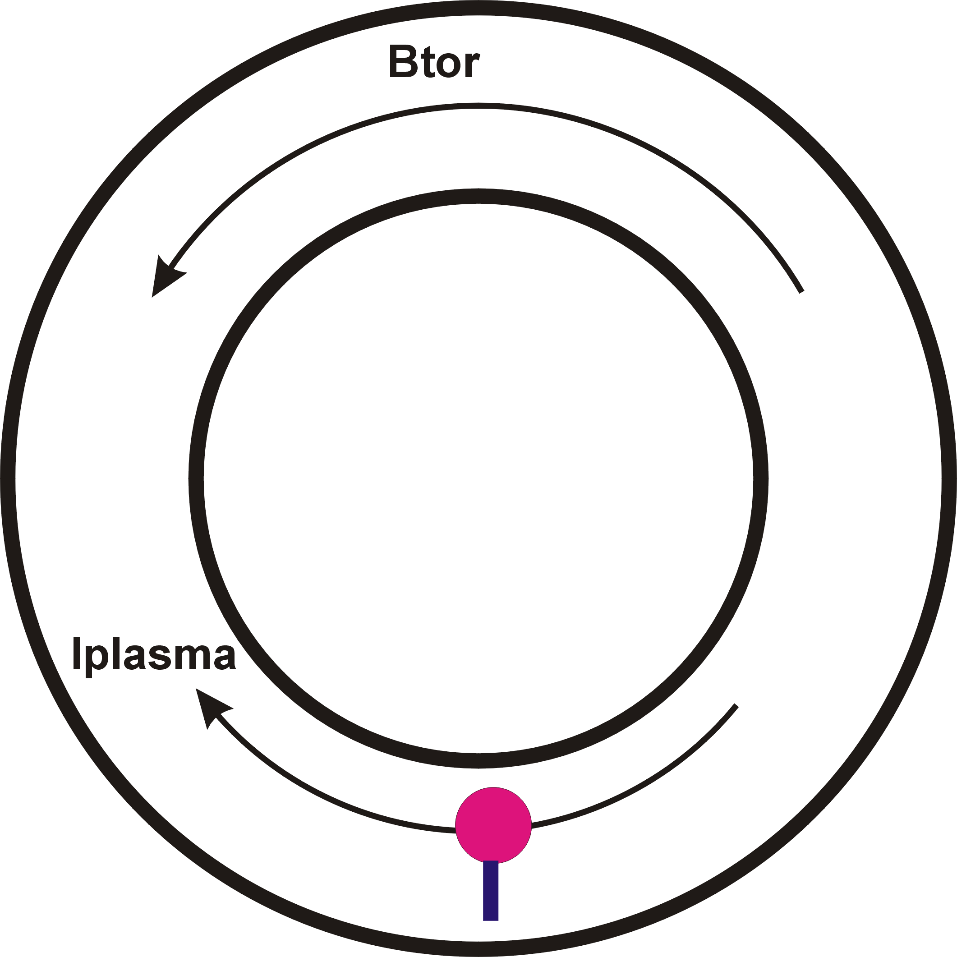
Fig. 2. Two orientation of the rake probe with respect to the toroidal magnetic field direction as seen from the top of the GOLEM. Left: Downstream orientation of the tips, Right: Low-Field side orientation of the tips.
It has to be noted that signals of the tips No 8,10 and 12 are not available for some reasons, most probably there were broken wires between the tips and the vacuum feedthrough.
Measurements were performed in series of reproducible discharges characterized by charging voltage of the condenser bank for the toroidal magnetic field U_{B} = 600 V, and the charging voltage of the condenser bank for the primary winding of the GOLEM transformer U_{CD} = 450 V., The time delay between triggers of these condenser banks is T_{CD} = 1000 μs. The pressure of the working gas (hydrogen) is P_{H2} = 16 mPa, and preionizacion was switched ON..
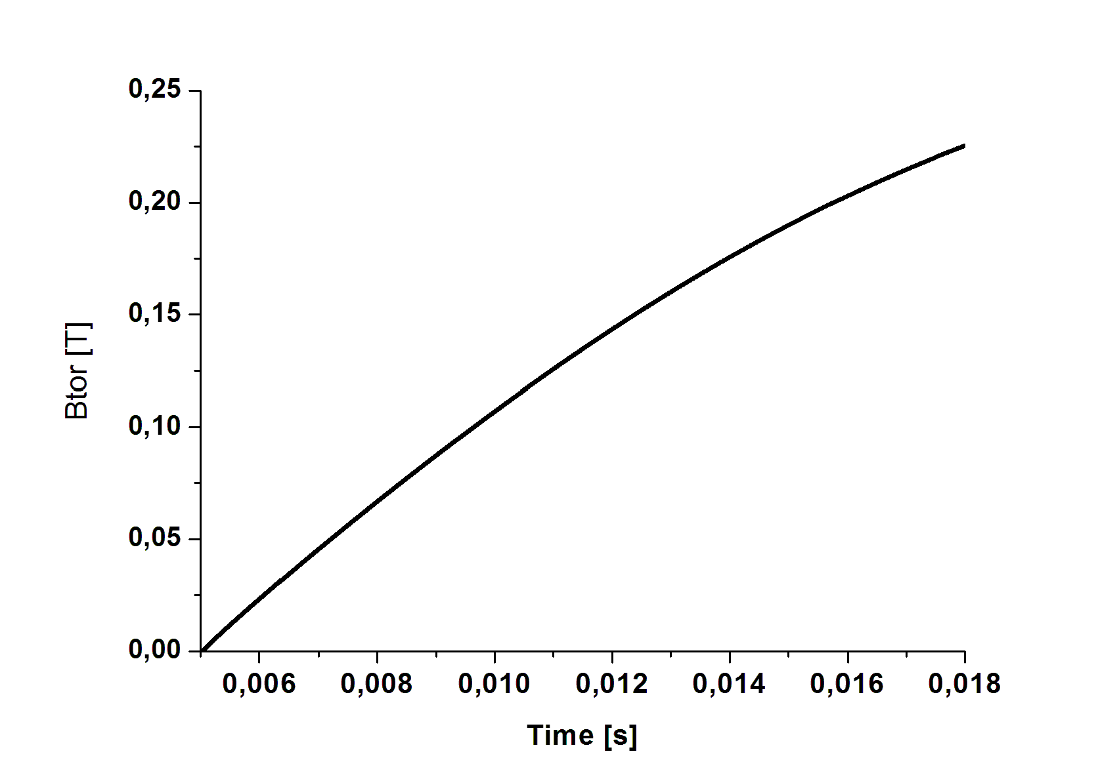
Toroidal magnetic field
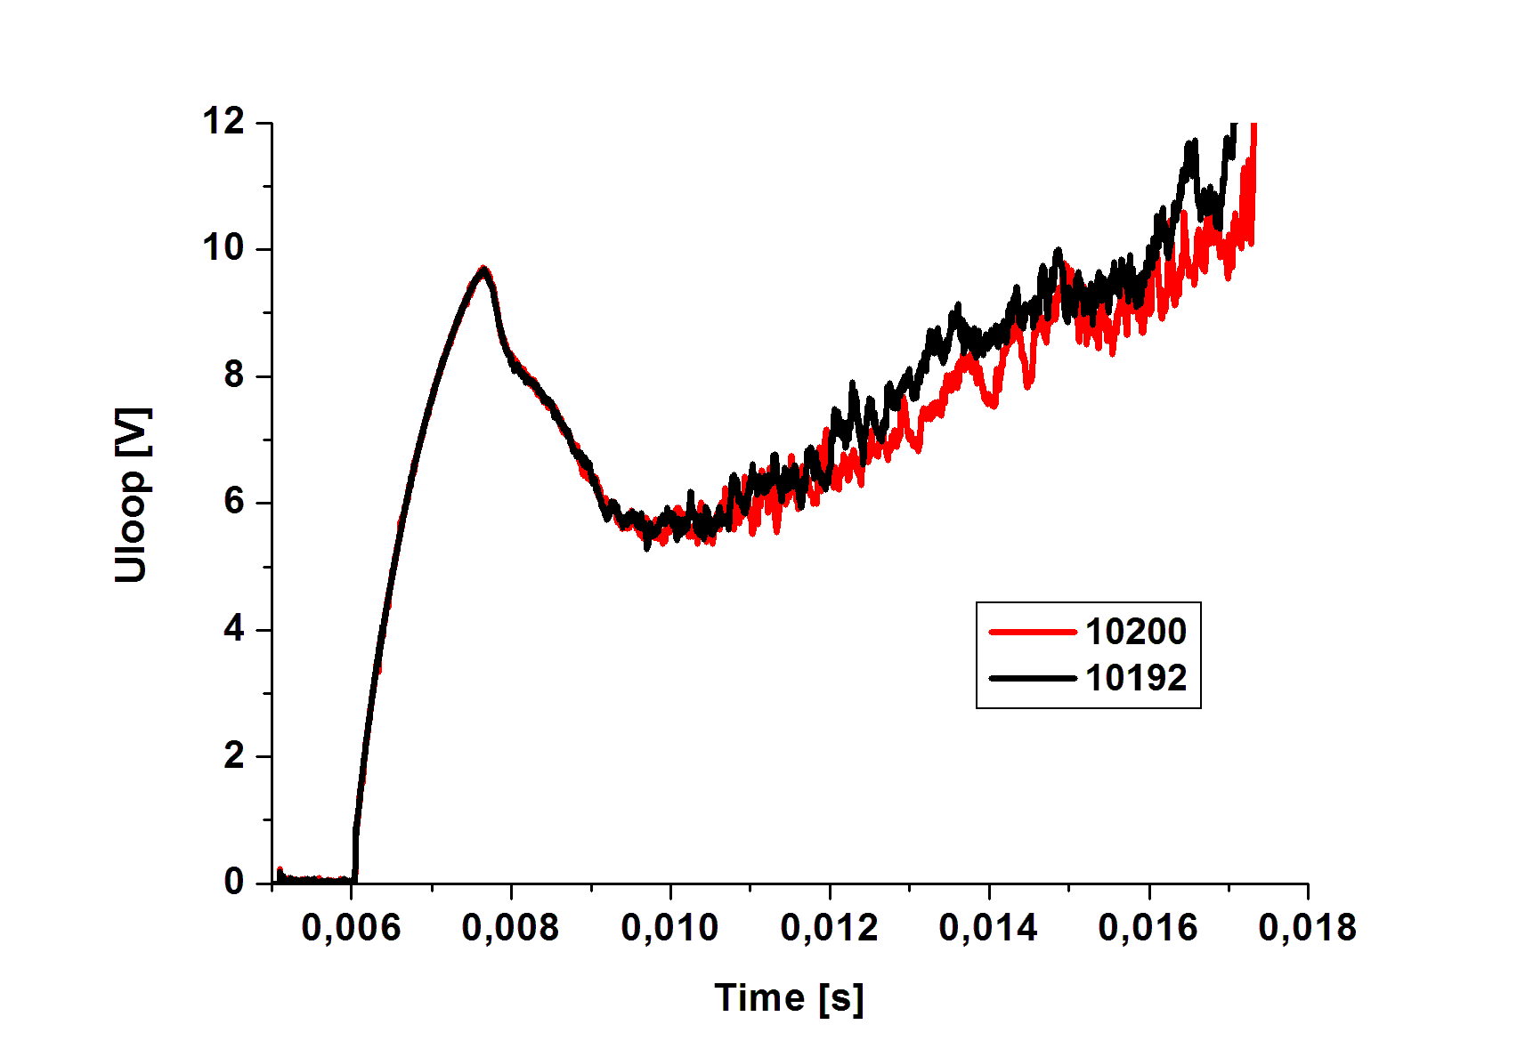
Loop voltage
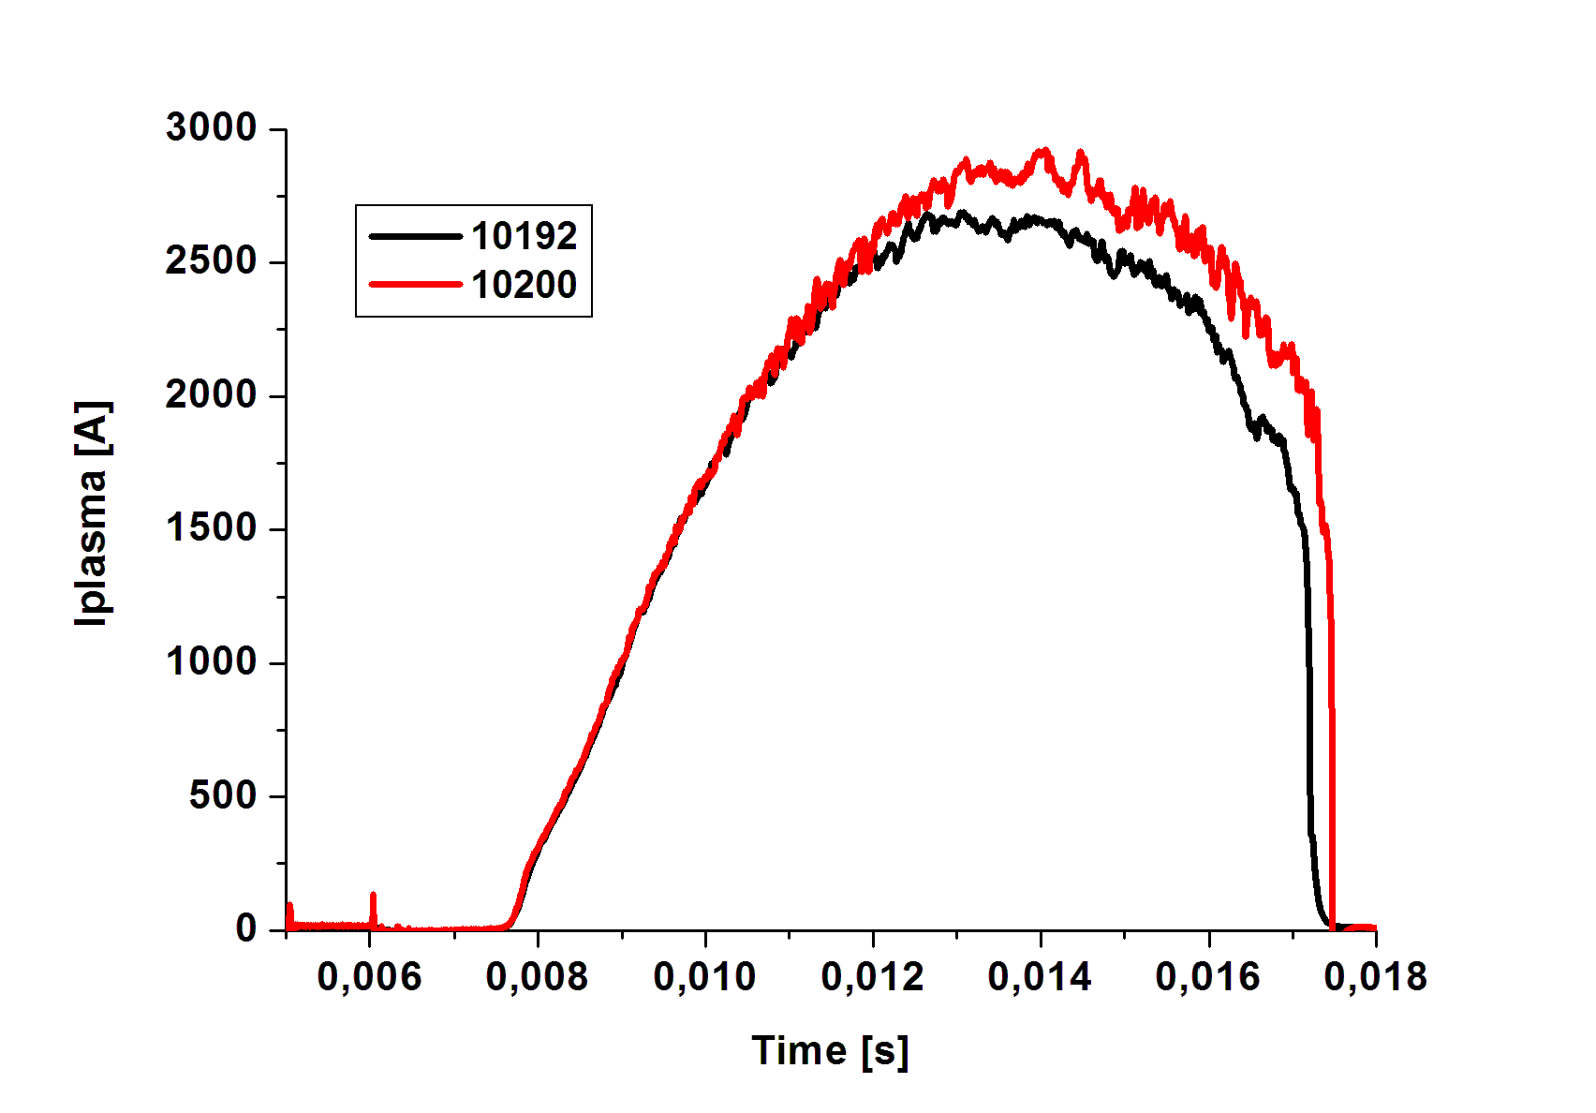
Plasma current
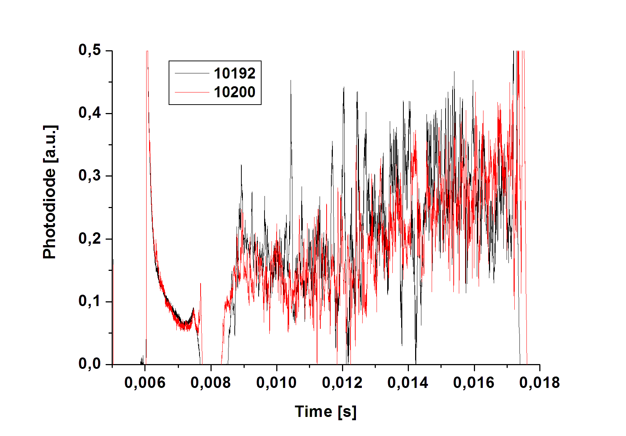
Signal of photodiode
It was not possible to measure simultaneously Isat, V1 and V3.
Therefore, the electron temperature and the ion saturation current were measured separately.
For measurements of the ion saturation current in the downstream orientation, the following combination of tips were used

# | 10192 | 10193 | 10194 | 10195 | 10196 | 10197 | 10198 | 10199 | 10200
Tips No | 1-2 | 2-3 | 3-4 | 4-5 | 5-6 | 6-7 | 7-8 | 7-9 | 9-11

To calculate the temperature was measured at V1 and V3 different probes. It is necessary to say that V1 correspond to the probe that is positively polarized and V3 is the probe that is floating, see Figure 1.

The measurement of the electron temperature with the downstream orientation was performed with following combination of the tips:

# | 10203 | 10204 | 10212 | 10213 | 10214 | 10215 | 10216 | 10217 | 10218 | 10219
Tips | 1.2.3 | 2.3.4 | 3.4.5 | 4.5.6 | 5.6.7 | 6.7.9 | 7.9.11 | 9.11.13 | 11.13.14 | 13,14,15

The measurement of the electron temperature with the rake probe tips oriented toward the low field side of the torus was performed with following combination of the tips:

# | 10220 | 10221 | 10222 | 10223 | 10224 | 10225 | 10226 | 10227 | 10228 | 10229
Tips | 1-2-3 | 2-3-4 | 3-4-5 | 4-5-6 | 5-6-7 | 6-7-9 | 7-9-11 | 9-11-13 | 11-13-14 | 13-14-15

Where the first number corresponds to the probe is floating, the second is the positively biased probe and the third probe that negatively polarized. The circuit according to the triple probe can be seen in Figure 3. Where polarization is made by the voltage 100 V supplied to the tips by 10 (11?) batteries connected in series. [8]

Results
To obtain the electron temperature, it was numerically solved the equation (5). Curves were obtained from electron temperature and saturation current. These are plotted individually below. Also plotted surface the temperature (in both orientations, DS and LFS) and Isat. Averages calculated over time, 7-9 ms, 11.9 ms, 11-13 ms, 13-15 ms, 15-17 ms, 17-19 ms, for Isat and electron temperature in both orientations.
From the graph for the orientation <Te> DS, it is seen that the maximum temperature is 15eV.
Temperature decreases for probes that are further away. From the graph for the orientation <Te> LFS, it is seen that the maximum temperature is 25eV. The temperature begins to rise up to 10ms and then begins to decrease, taking 15eV value below. From the graph orientation <Isat> for DS, begins to climb to 10ms and then begins to decrease.

